**Preamble**

You are expected to create a utility SwiftUI application to solve the area and perimeter of a right-angled triangle using the **Pythagoras** theorem. The required formulas are as follows,

1. Description of the right-angled triangle.

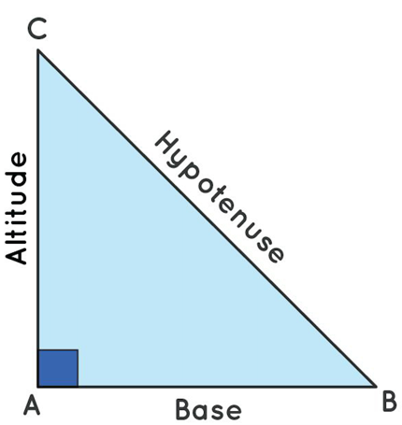

1. The **Pythagoras** theorem formula for a right-angled triangle.

If **a** → Altitude, **b** → Base and **c** → Hypotenuse then,

1. The Area of the right triangle.

1. The perimeter of the right triangle.

Before the assessment begins, do the following:

1. Create a SwiftUI application named RightTriangleSolver.
2. Ensure the project runs.
3. Unzip the provided assets and import the images into the project by dragging the file into the **Assets** catalogue (Rename the file as you wish).

**Instructions**

Build a SwiftUI Application with the below requirements.

The application only allows users to input 2 side length values of the right-angled triangle.

For example, among the base, altitude, and hypotenuse slides users are only allowed to input length values for base and altitude and they should be able to mark hypotenuse length as an unknown value.

Based on the given 2 inputs you are required to calculate,

1. The unknown side length.
2. The area of the right-angled triangle.
3. The perimeter of the right-angled triangle.

From the above example, after the user selected hypotenuse length as an unknown value, you are supposed to gather base, and altitude length values from the user and the calculate hypotenuse length value first and then area, and perimeter accordingly.

Finally, you are supposed to display the last calculated results on another screen every time the user opens the app (The last calculated results must be persistence).

**User Interfaces**

**Calculation View**

|  |  |  |
| --- | --- | --- |
|  |  |  |

**History View**

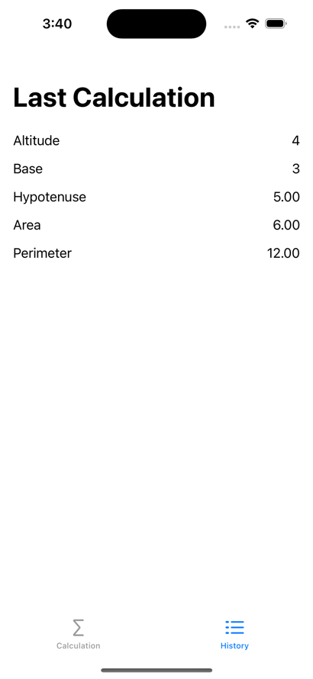

**More Details**

1. The image in the UI should not be cropped.
2. Based on the user-selected unknown side length, dynamically display text fields.

|  |  |
| --- | --- |
| Use case 1 | The base side length of the right-angled triangle is unknown. |
| Expected input fields | Altitude and hypotenuse |
| Expected output | The calculated value for the base side length  Area  Perimeter |

|  |  |
| --- | --- |
| Use case 2 | The altitude side length of the right-angled triangle is unknown. |
| Expected input fields | Base and hypotenuse |
| Expected output | The calculated value for the altitude side length  Area  Perimeter |

|  |  |
| --- | --- |
| Use case 3 | The hypotenuse side length of the right-angled triangle is unknown. |
| Expected input fields | Base and Altitude |
| Expected output | The calculated value for the hypotenuse side length  Area  Perimeter |

1. Implement a function to calculate the unknown side length.
2. Implement a function to calculate the area of the right-angled triangle.
3. Implement a function to calculate the perimeter of the right-angled triangle.
4. Output is only shown when the user taps on the calculate button.
5. The last calculated result data should be displayed on the new screen, and it must persist. (You can use @AppStorage).
6. On change of choosing an unknown edge (selected picker value), you are supposed to hide the output details and clear the textfield inputs. But make sure last calculated data is persist and displayed in the History view.
7. You should avoid any app breaking/crashing.